Motorola, one of the world’s leading manufacturers and suppliers of

semiconductors and electronic equipment systems for civil and military

applications, introduced the concept of six-sigma process quality to enhance the reliability and quality of their products, and cut product cycle times and expenditure on test/repair. Motorola used the following statement to explain:

*Sigma is a statistical unit of measurement that describes the distribution about the mean of any process or procedure. A process or procedure that can achieve plus or minus six-sigma capability can be expected to have a defect rate of no more than a few parts per million, even allowing for some shift in the mean. In statistical terms, this approaches zero defects.*

The approach was championed by Motorola’s chief executive officer at the

time, Bob Galvin, to help improve competitiveness. The six-sigma approach became widely publicized when Motorola won the US Baldrige National Quality Award in 1988.

Six-sigma is a disciplined approach for improving performance by focusing

on producing better products and services faster and cheaper. The emphasis is on improving the capability of processes through rigorous data gathering, analysis and action, and:

* enhancing value for the customer;
* eliminating costs which add no value (waste).

Unlike simple cost-cutting programmes six-sigma delivers cost savings

whilst retaining or even improving value to the customers.

**Why six-sigma?**

In a process in which the characteristic of interest is a variable, defects are usually defined as the values which fall outside the specification limits (LSL–USL). Assuming and using a normal distribution of the variable, the

percentage and/or parts per million defects can be found.

For example, in a centred process with a specification set at ***x ± 3σ*** there

will be 0.27 per cent or 2700 ppm defects. This may be referred to as ‘an

unshifted ± 3 sigma process’ and the quality called ‘±3 sigma quality’. In an ‘unshifted ± 6 sigma process’, the specification range is ***x ± 6σ*** and it produces only 0.002 ppm defects.

It is difficult in the real world, however, to control a process so that the

mean is always set at the nominal target value – in the centre of the

specification. Some shift in the process mean is expected.

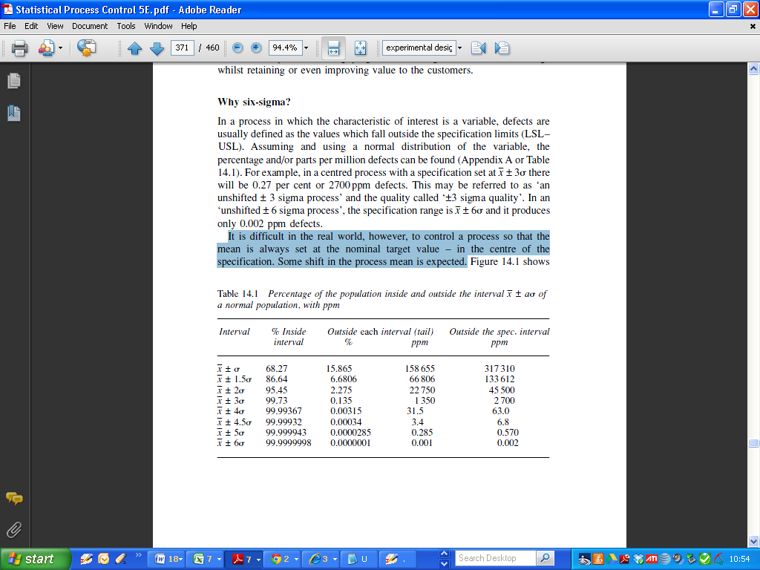

*Percentage of the population inside and outside the interval of a normal population, with ppm*

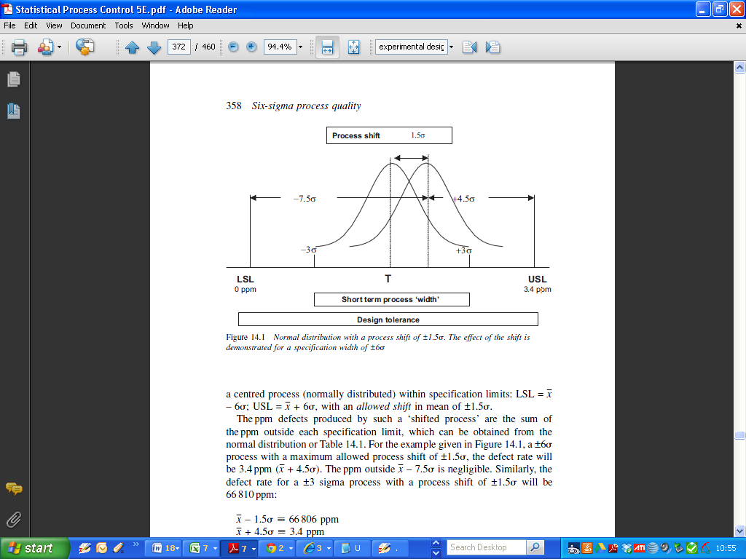

a centred process (normally distributed) within specification limits: LSL = ***x - 6σ*** USL = ***x + 6σ*** with an allowed shift in mean of ±1.5 ***σ***.

The ppm defects produced by such a ‘shifted process’ are the sum of

the ppm outside each specification limit, which can be obtained from the

normal distribution.

For the example, a ***±6 σ*** process with a maximum allowed process shift of ***±1.5 σ*** the defect rate will be 3.4 ppm (***x + 4.5σ***).

The ppm outside ***x – 7.5σ*** is negligible. Similarly, the defect rate for a ±3 sigma process with a process shift of ±1.5 ***σ*** will be 66,810 ppm:

feature is not as obvious when the linear measures of process capability Cp/

Cpk are used:

±6 sigma process _ Cp/Cpk = 2

±3 sigma process _ Cp/Cpk = 1

This leads to comparative sigma